**Format for uploading details in GitHub and Slack in word file format**

**Student Name: Shreetal Kalabandi**

**Class and Sec: VI B**

**USN: 4AL17CS091**

|  |  |  |  |  |
| --- | --- | --- | --- | --- |
| **Online Test Details** | | | | |
| **Subject** | **Computer Graphics and Visualization** | | | |
| **Semester** | **VI - B** | | **Duration** | **30 Minutes** |
| **99%** | | **29/30** | | |

**Encl: snapshot of the test result**

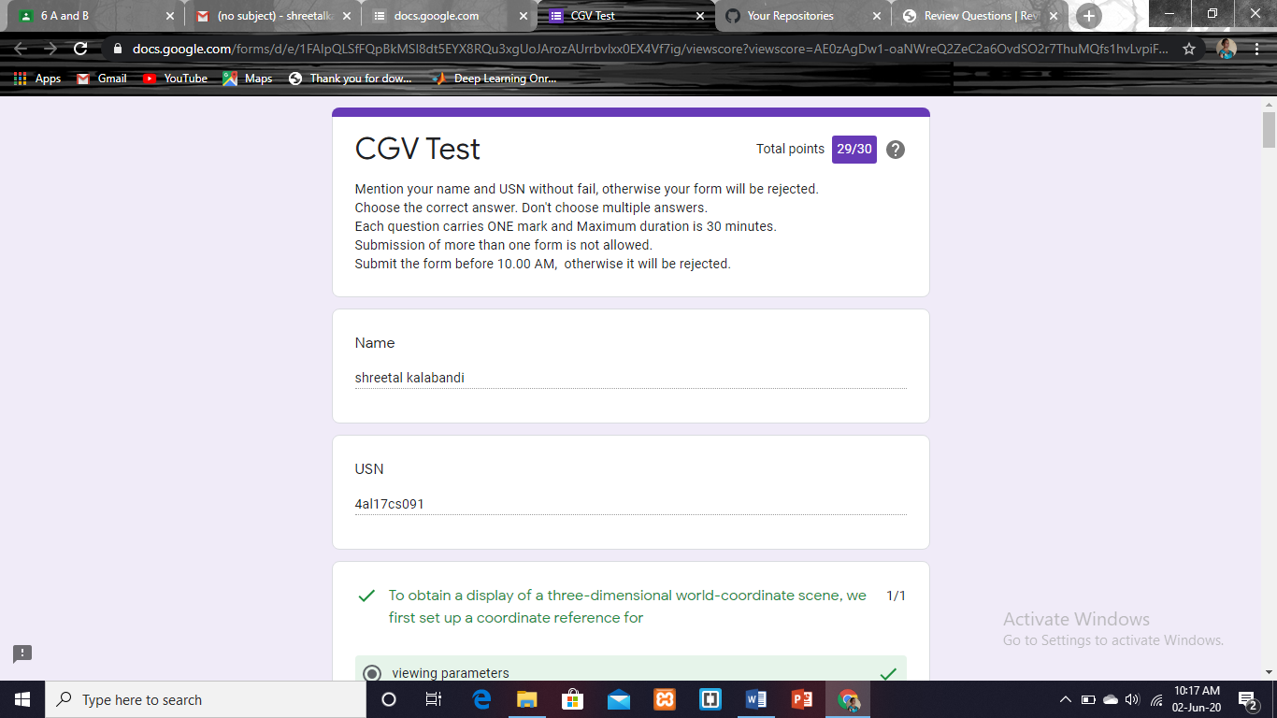

|  |  |  |  |
| --- | --- | --- | --- |
| **Certification Course Details** | | | |
| **Course** | **Blockchain Essentials** | | |
| **Certificate Provider** | **Cognitiveclass.ai** | **Duration** | **6 hours** |

**Encl: snapshots of the daily class activities (at least two snap shots)**

**Progress on 02-06-2020**

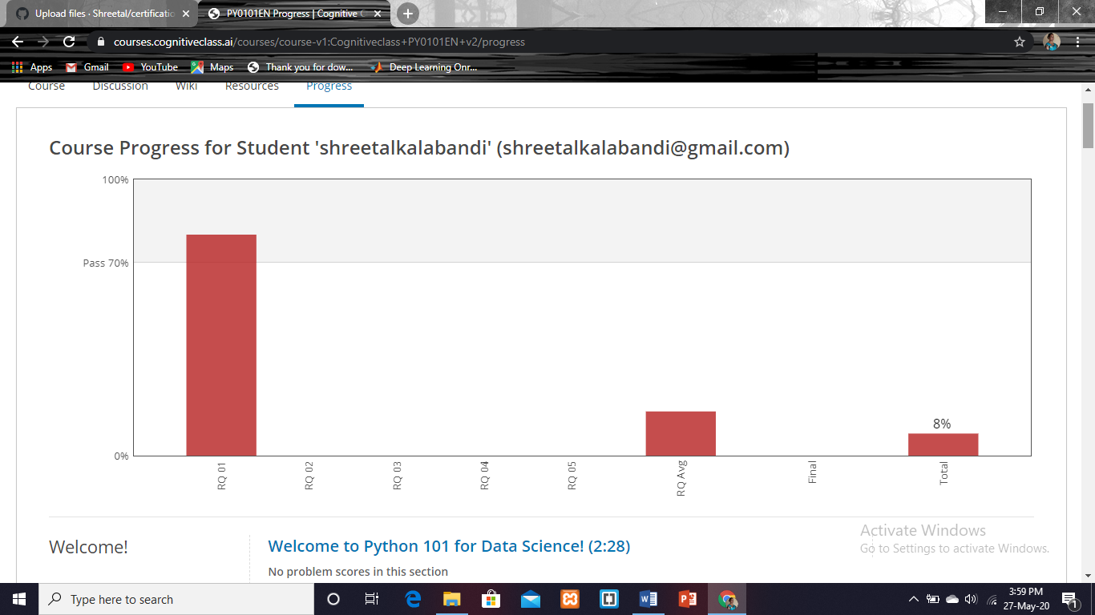

|  |  |
| --- | --- |
| **Coding Challenges** | |
| **Problem Statement: Pro1(python),Pro2(java),Pro3(c).** | |
| **Status: Completed** | |
| **Uploaded the report both in GitHub & Slack** | **Yes** |

**Encl: snapshots of your response to challenge.**

